Name: Mrs. Rupali N Hosmani.

Course: Executive Post Graduate Certification in Cloud Computing

Contact No. 7720003531

Assignment 3: IAM & Cloudwatch

**IAM:**

**A. Tasks To Be Performed:**

1. Create 4 IAM users named “Dev1”, “Dev2”, “Test1”, and “Test2”.

2. Create 2 groups named “Dev Team” and “Ops Team”.

3. Add Dev1 and Dev2 to the Dev Team.

4. Add Dev1, Test1 and Test2 to the Ops Team

**B. Tasks To Be Performed:**

1. Create policy number 1 which lets the users to: a. Access S3 completely b. Only create EC2 instances c. Full access to RDS

2. Create a policy number 2 which allows the users to: a. Access CloudWatch and billing completely b. Can only list EC2 and S3 resources

3. Attach policy number 1 to the Dev Team from task 1

4. Attach policy number 2 to Ops team from Task1.

**C. Tasks To Be Performed:**

1. Create a role which only lets user1 and user2 from task 1 to have complete access to VPCs and DynamoDB.

2. Login into user1 and shift to the role to test

**CLOUDWATCH:**

**D. Tasks To Be Performed:**

1. Create a dashboard which lets you check the CPU utilization and networking for a particular EC2 instance.

**E .Tasks To Be Performed**:

1. Create a CloudWatch billing alarm which goes off when the estimated charges go above $500.

2. Create a CloudWatch alarm which goes off to an Alarm state when the CPU utilization of an EC2 instance goes above 65%. Also add an SNS topic so that it notifies the person when the threshold is crossed.

**IAM**

Step A:

1. Creating IAM Users & Groups

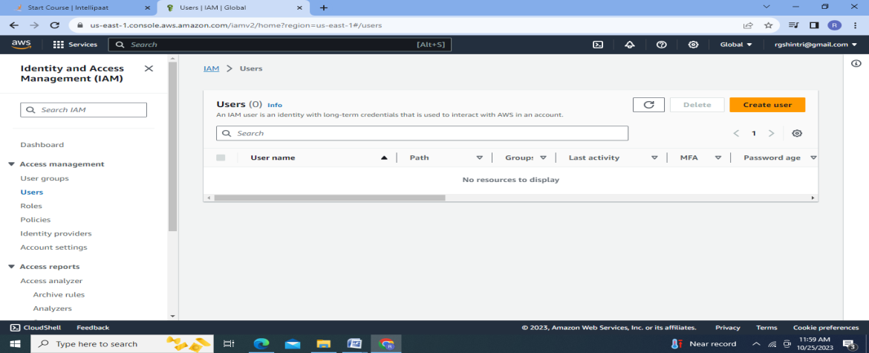

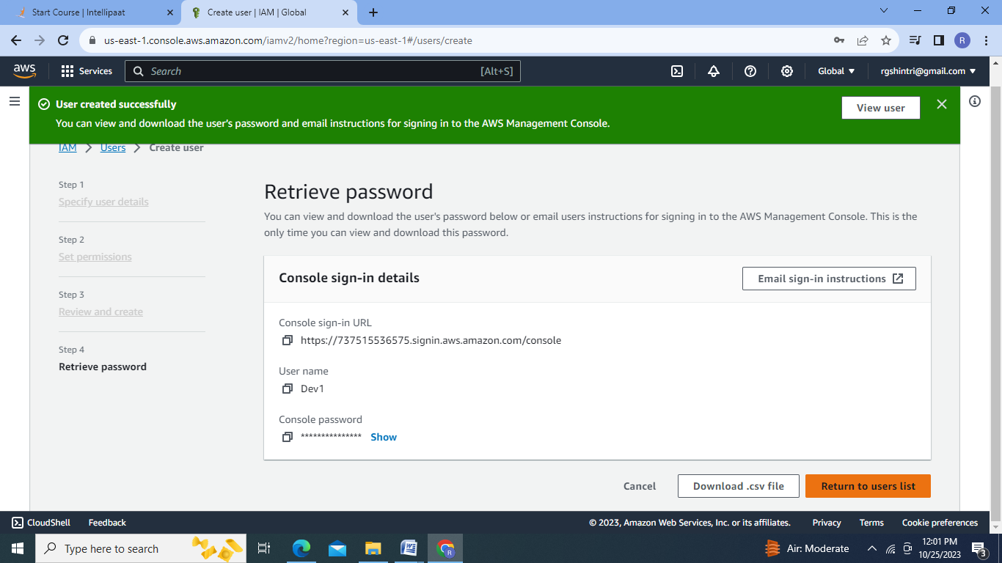

2.CSVfile :

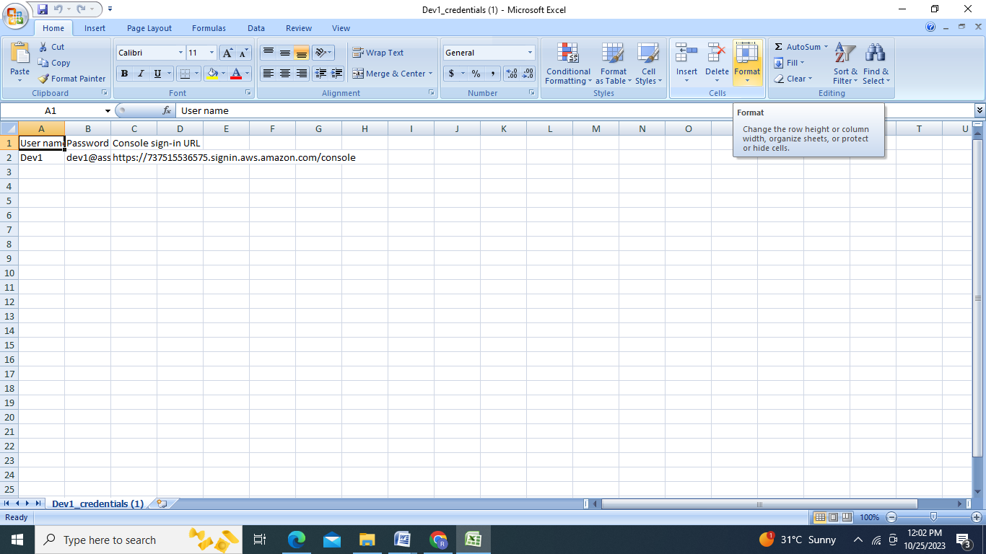

3.4Users crated as Dev1,Dev2,Test1,Test2:

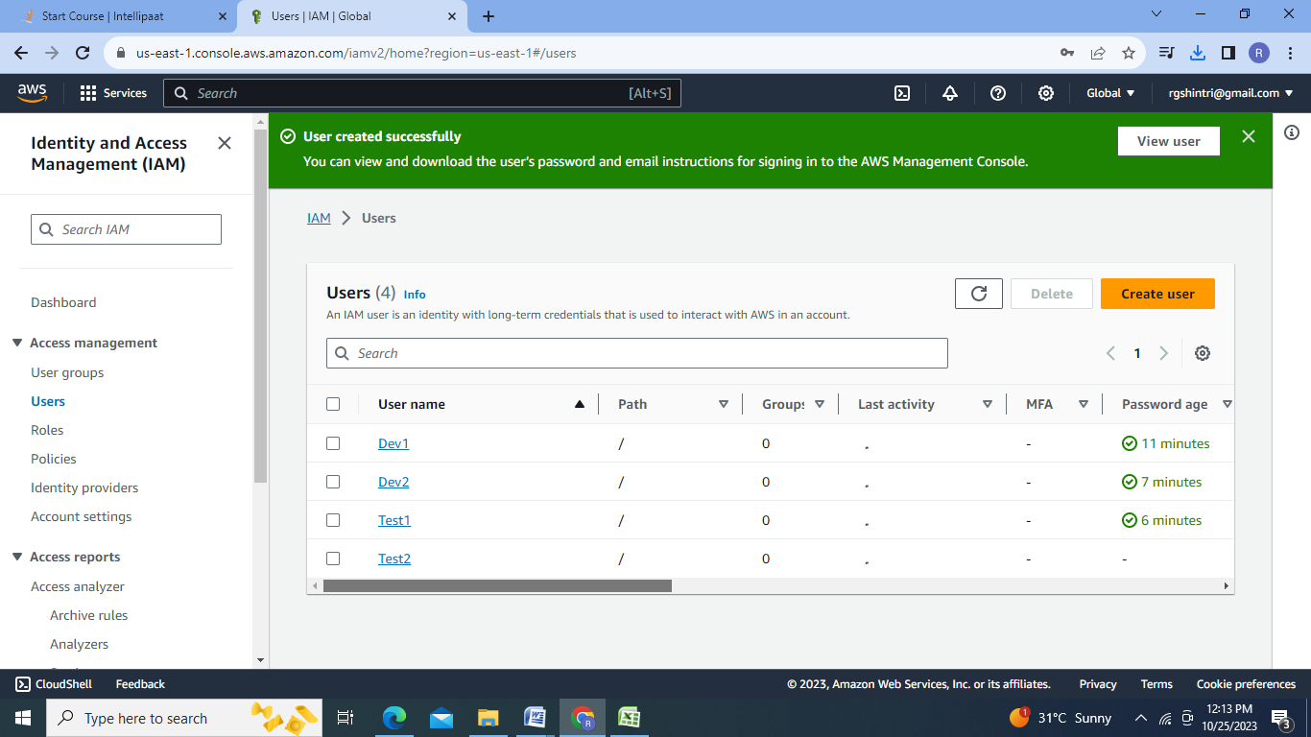

4.Create User Group:

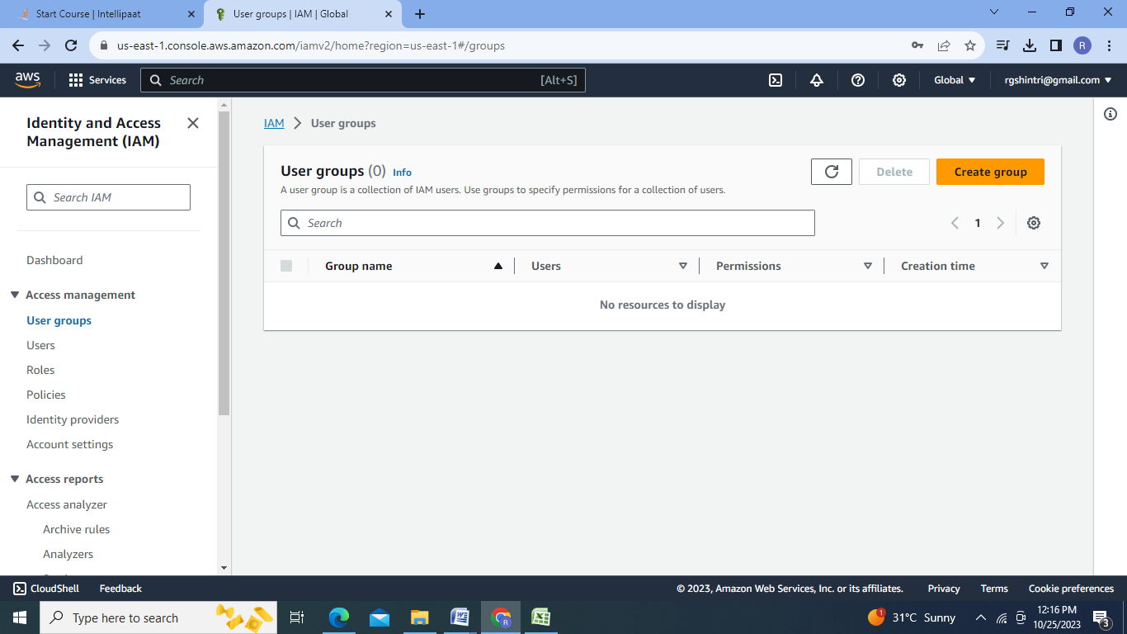

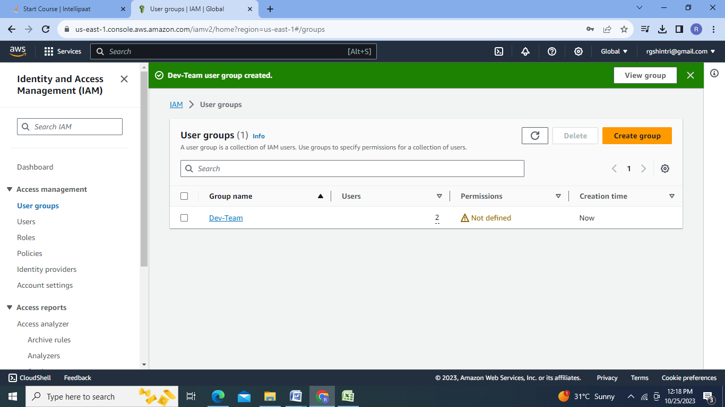

5.User groups created as Dev Team & Ops Team:

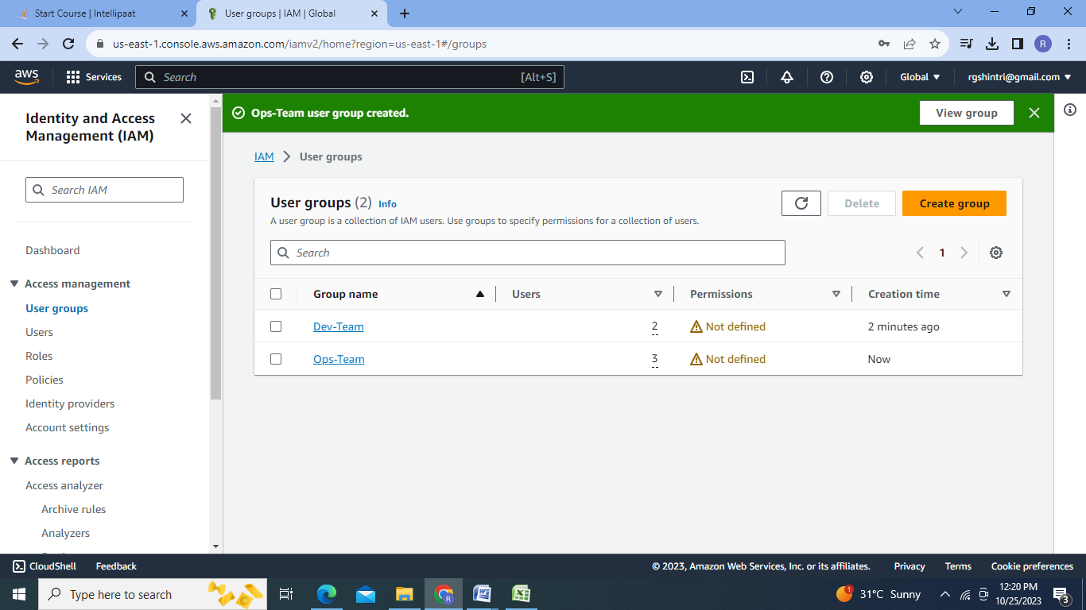

Step B:Creating policies & Attaching with the user groups:

1.Policy1:

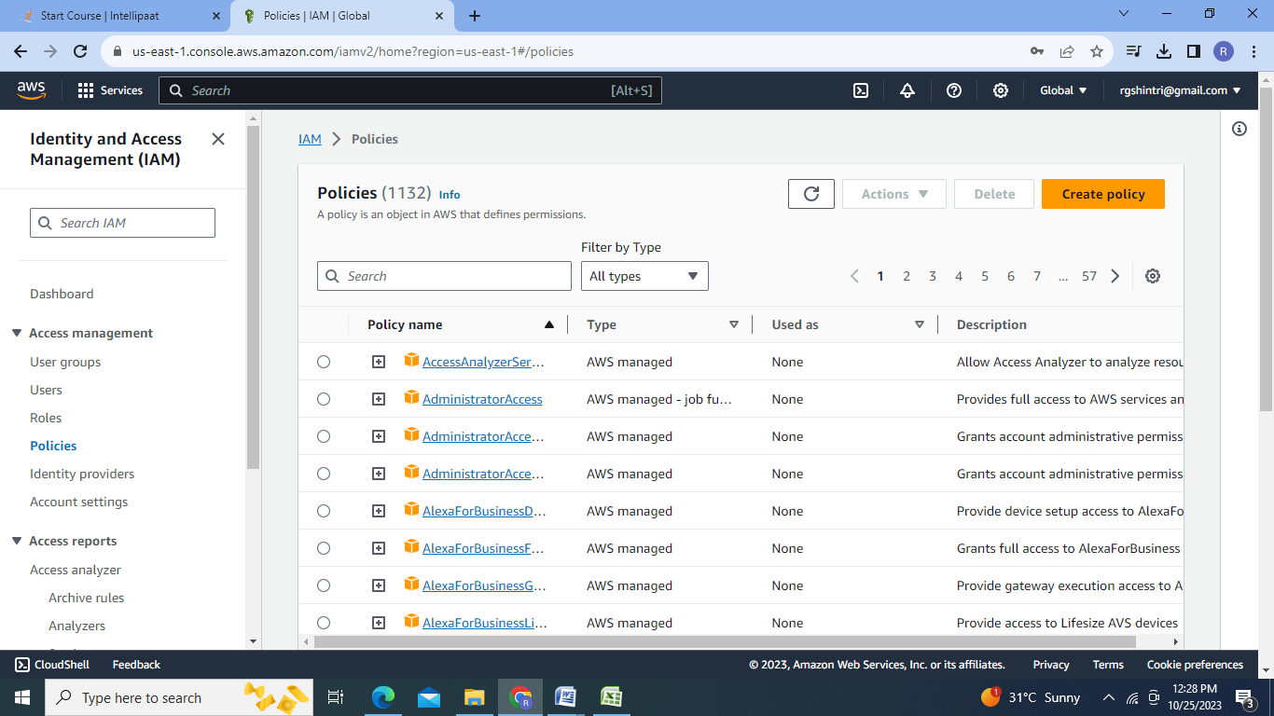

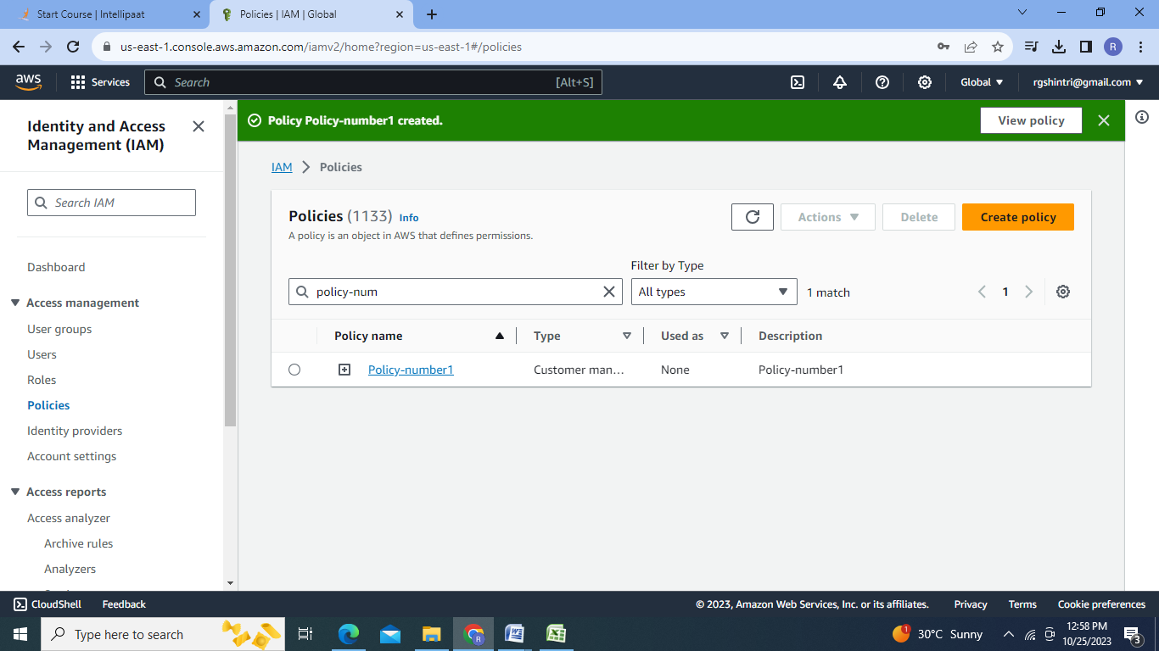

1. Policy 2:

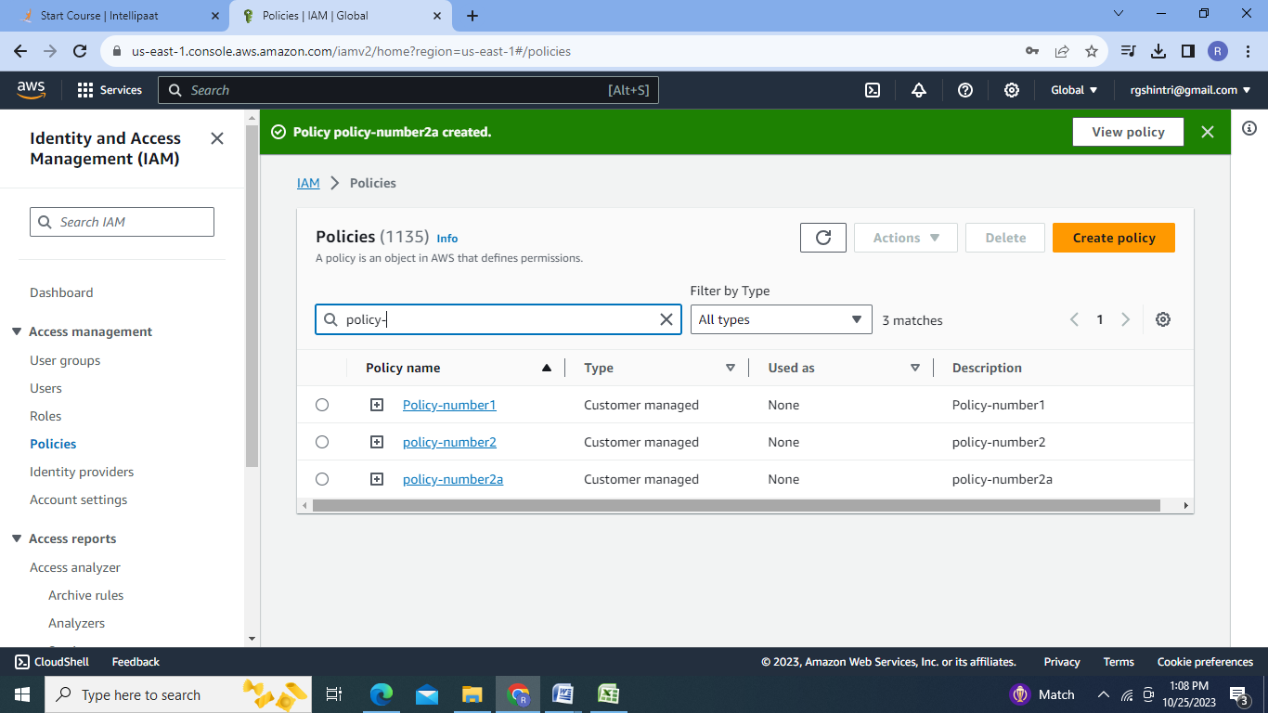

3.Attaching policies:

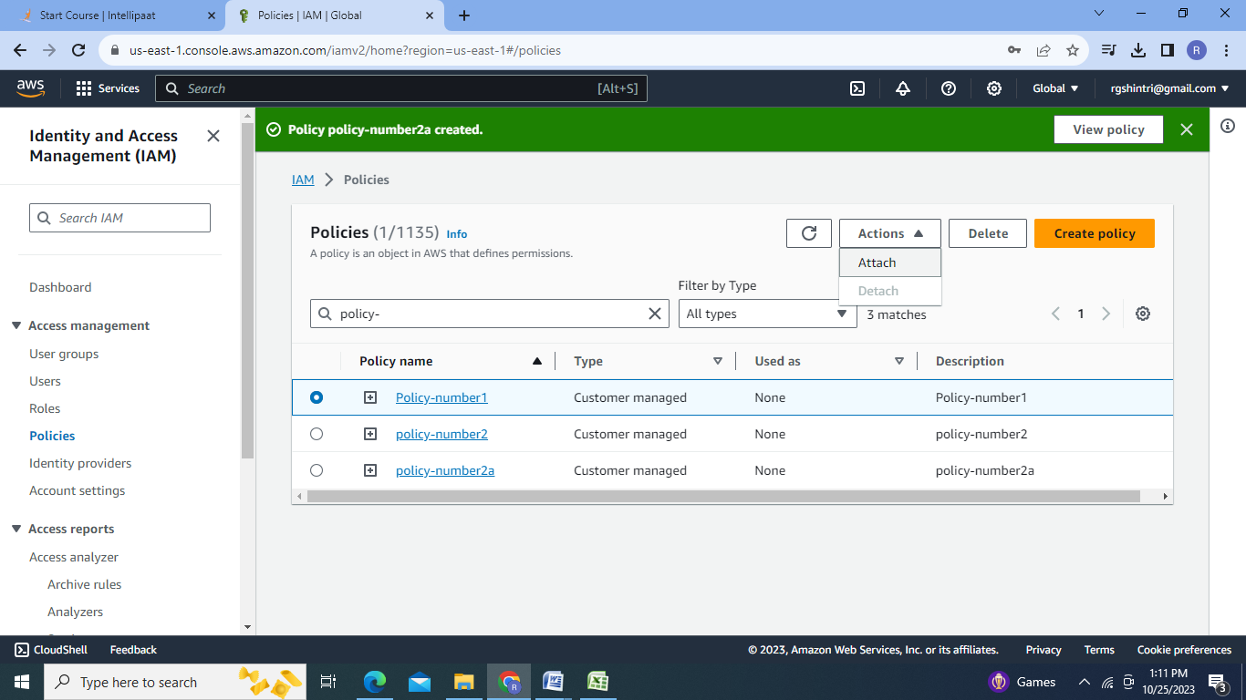

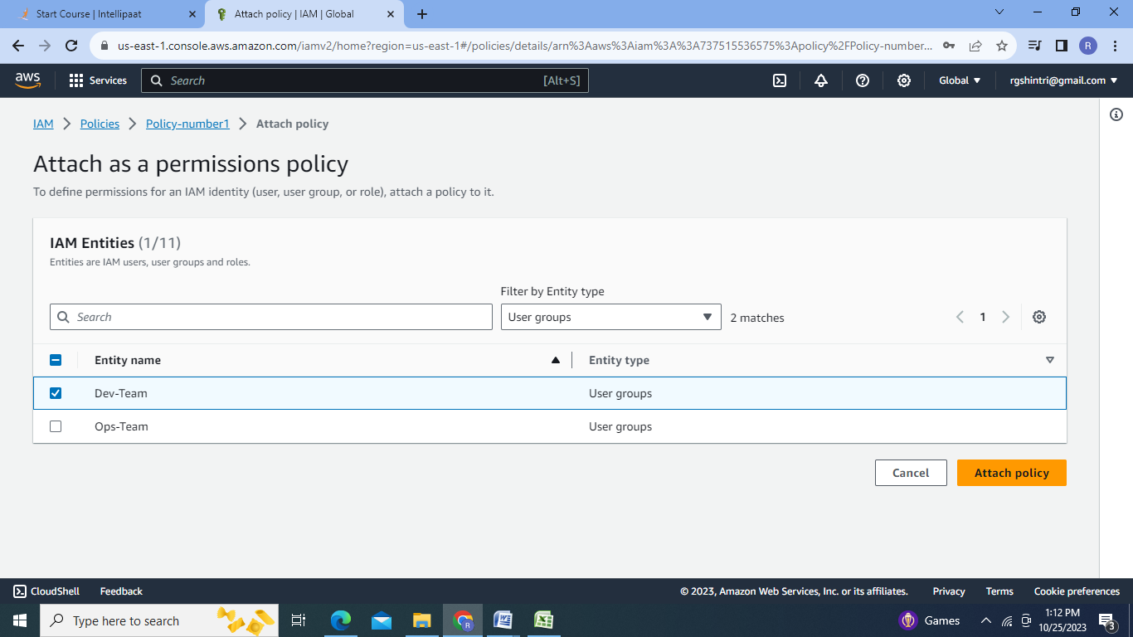

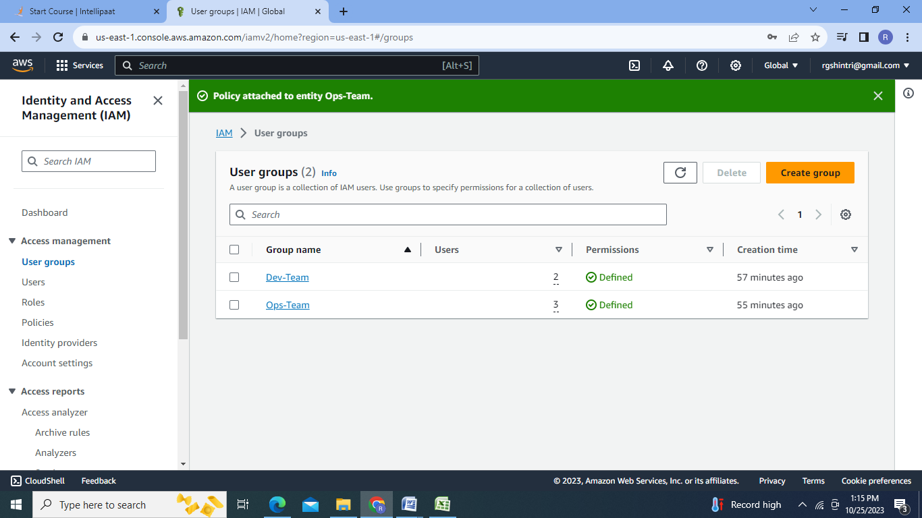

Step C:Creating Roles & Testing:

1.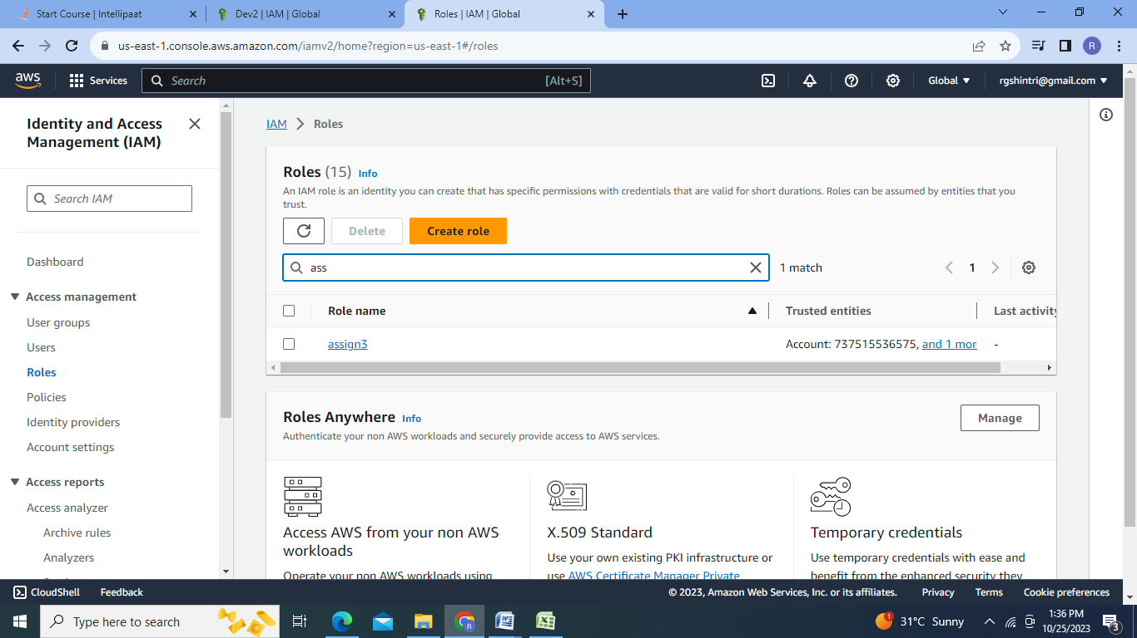

2.

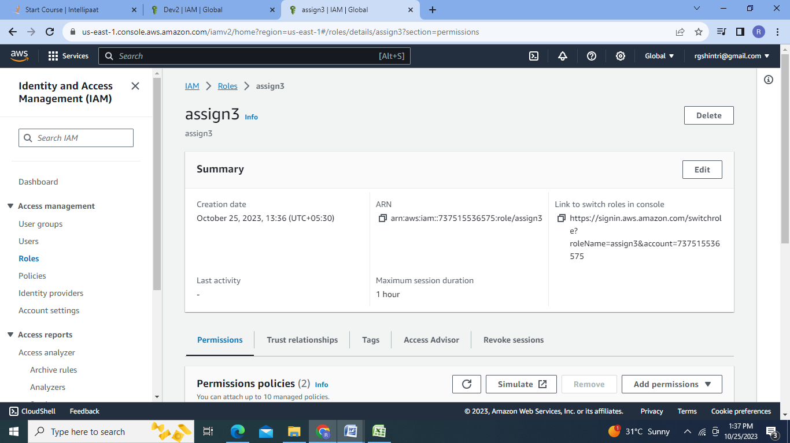

3.Testing:Permissions

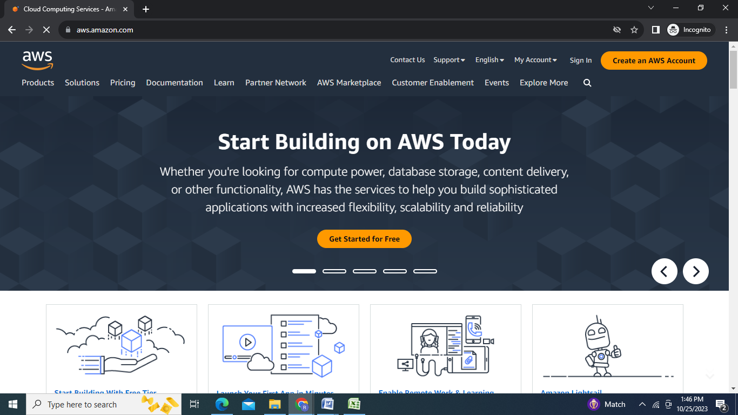

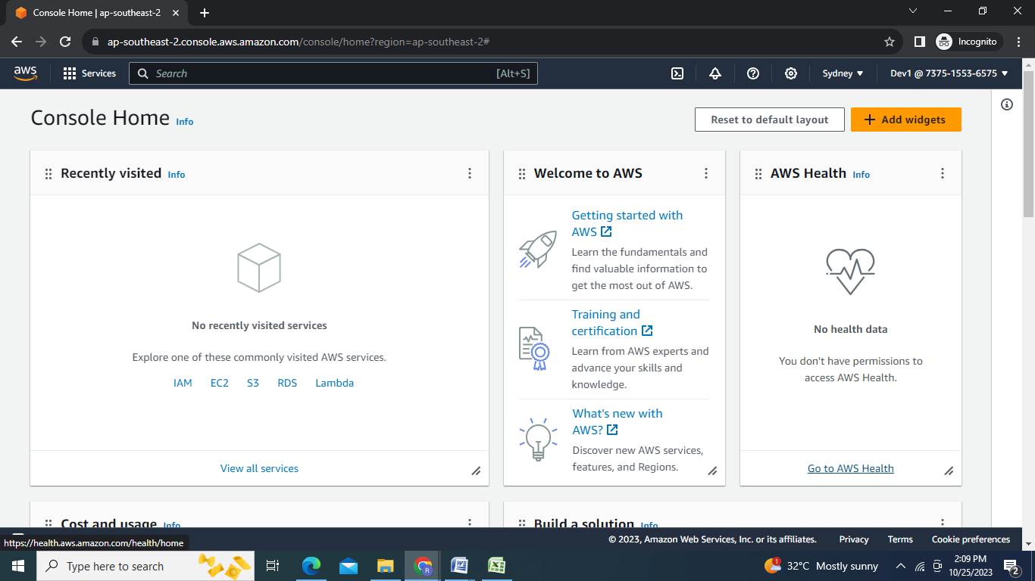

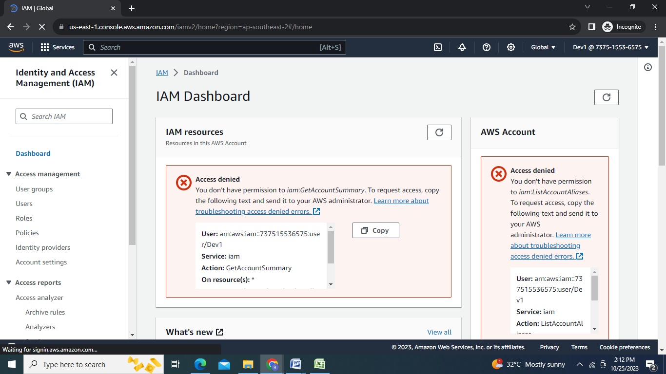

4.Testing:Role

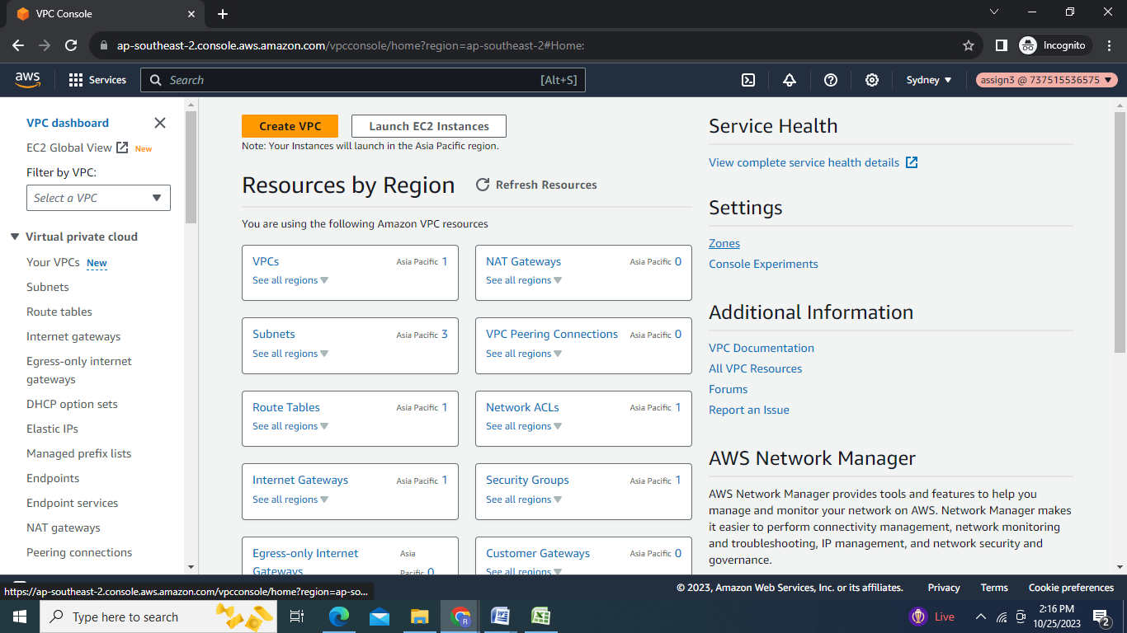

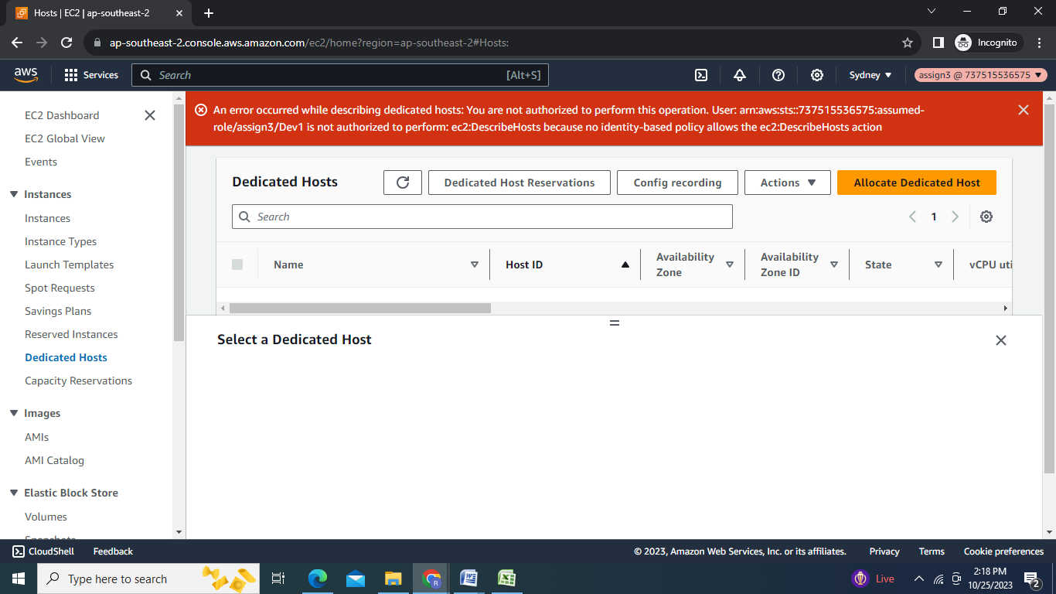

**Cloudwatch:**

Step D:

1.Cloudwatch Dashboard : EC2 cpu utilization & Networking:

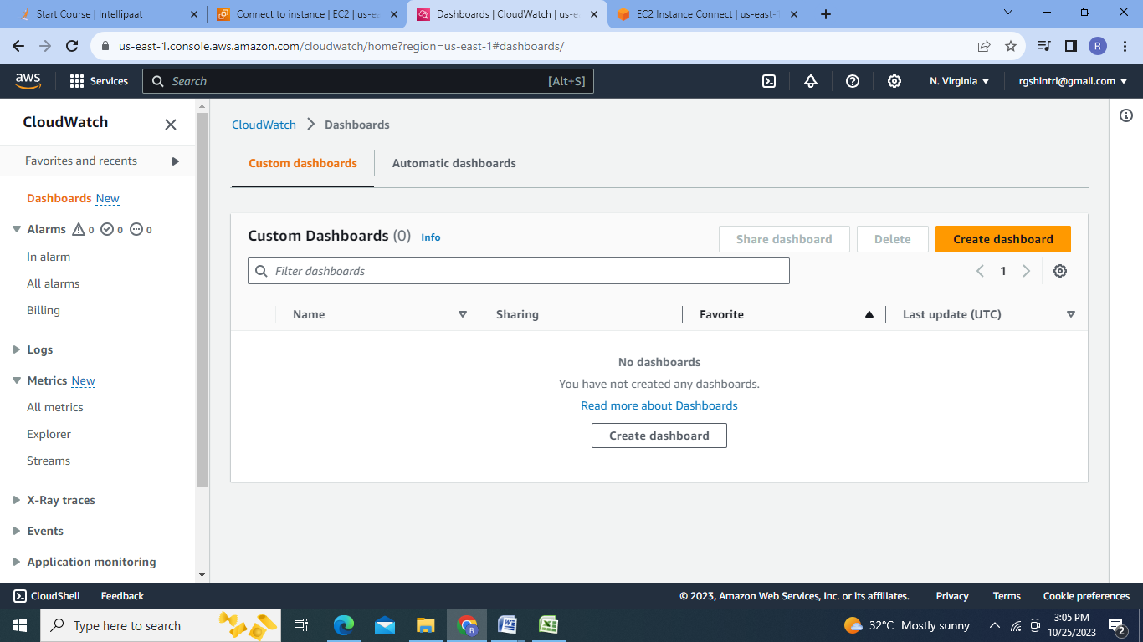

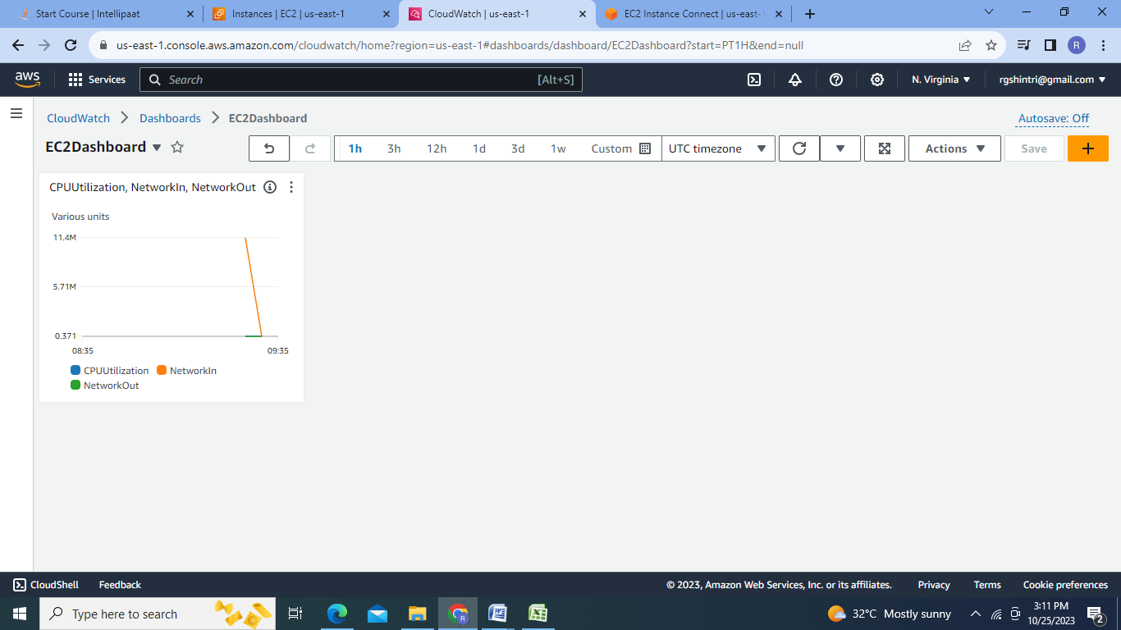

Step E: Creating Cloudwatch Alarms:

1.Billing Alarm:

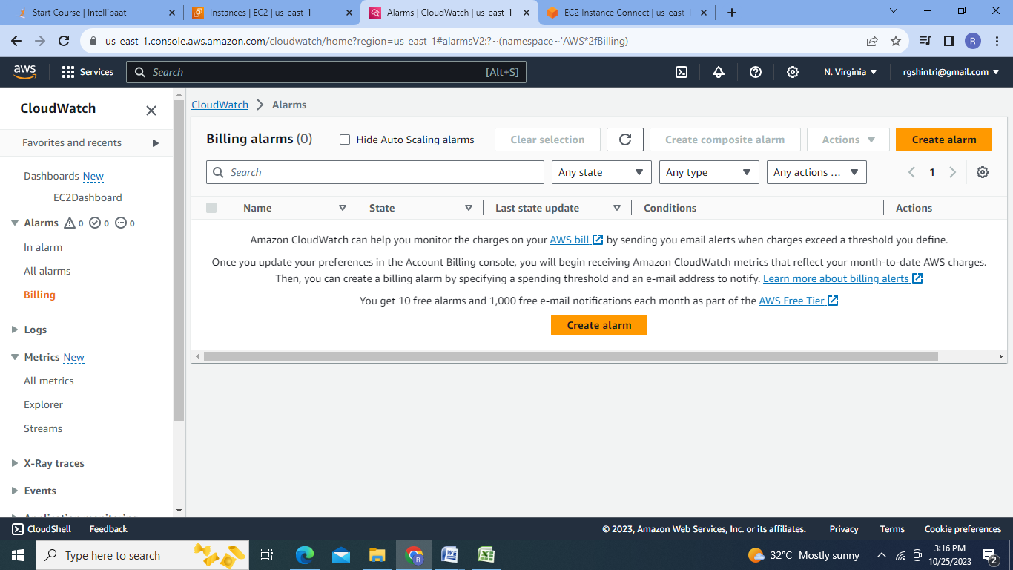

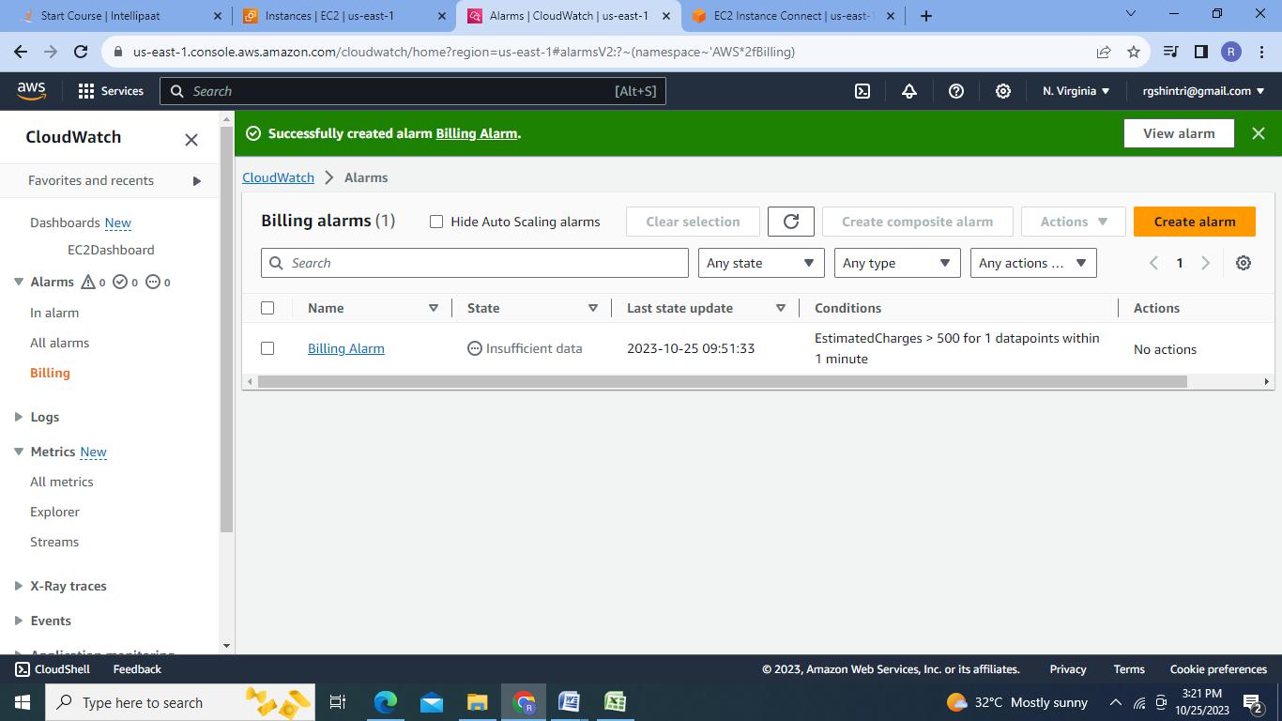

2.CPU Utilization above 65%:

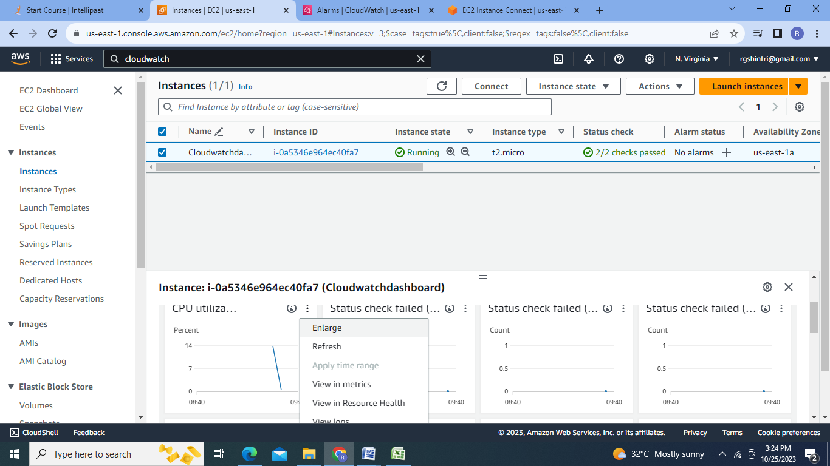

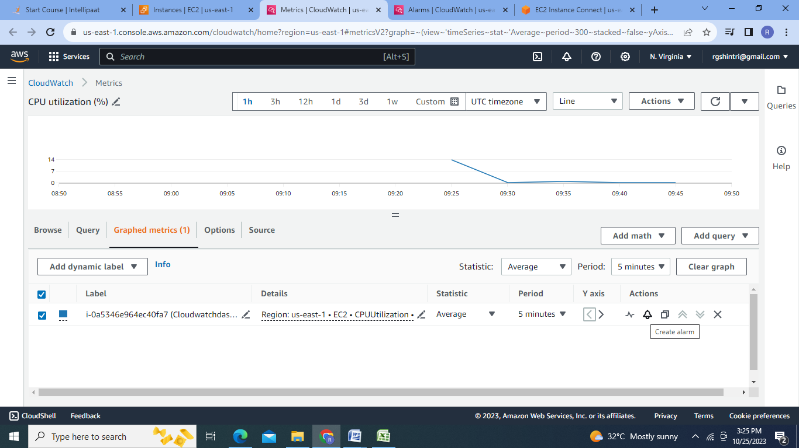

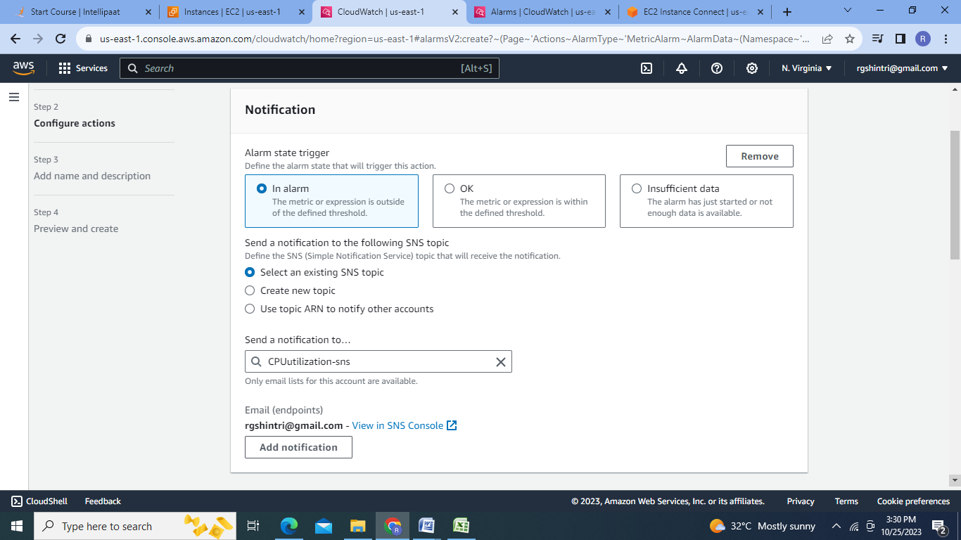

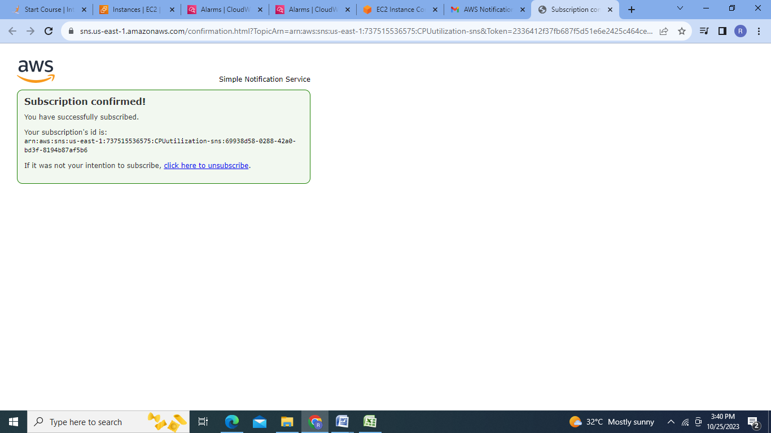

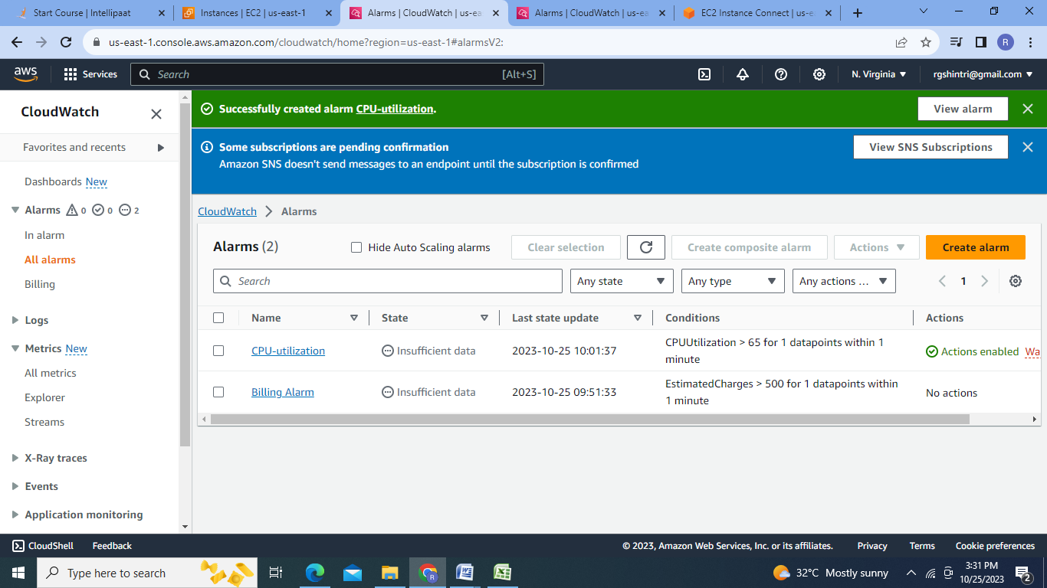

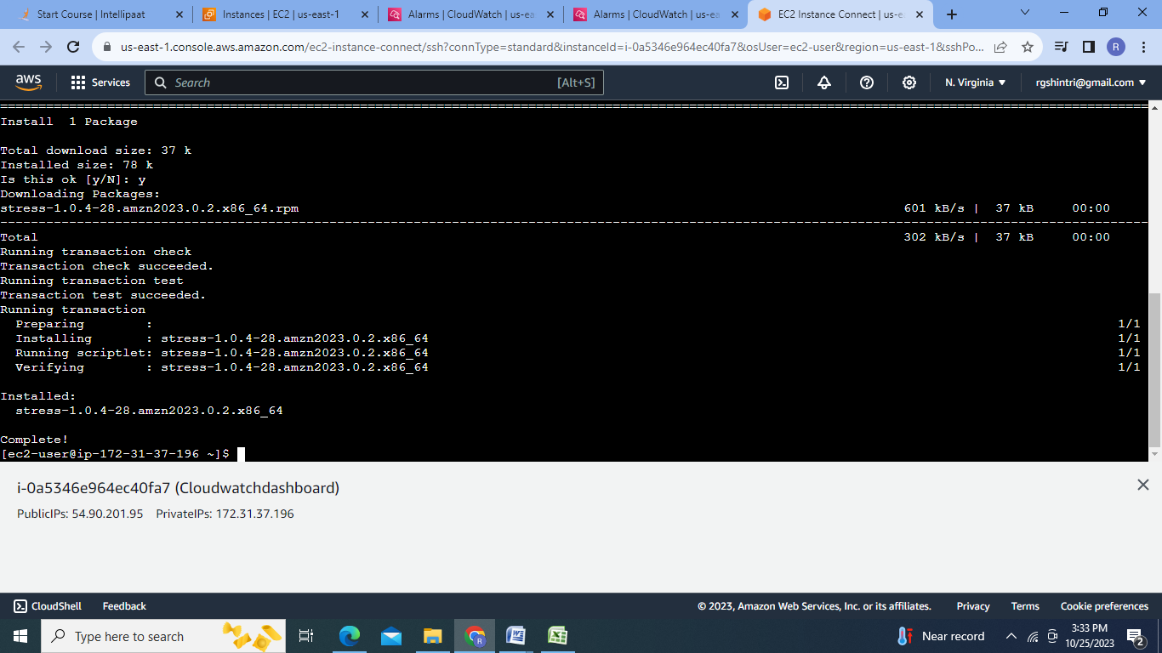

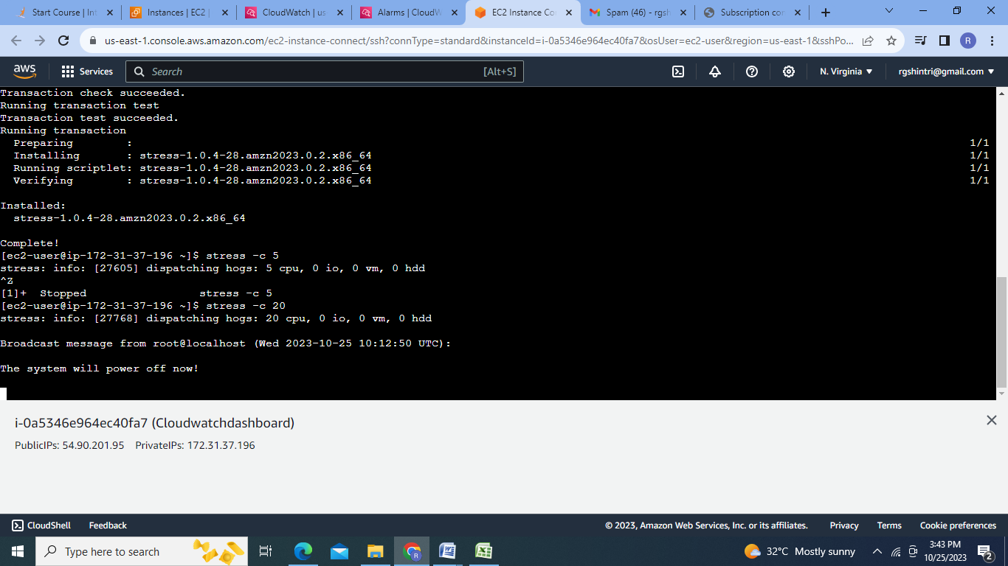

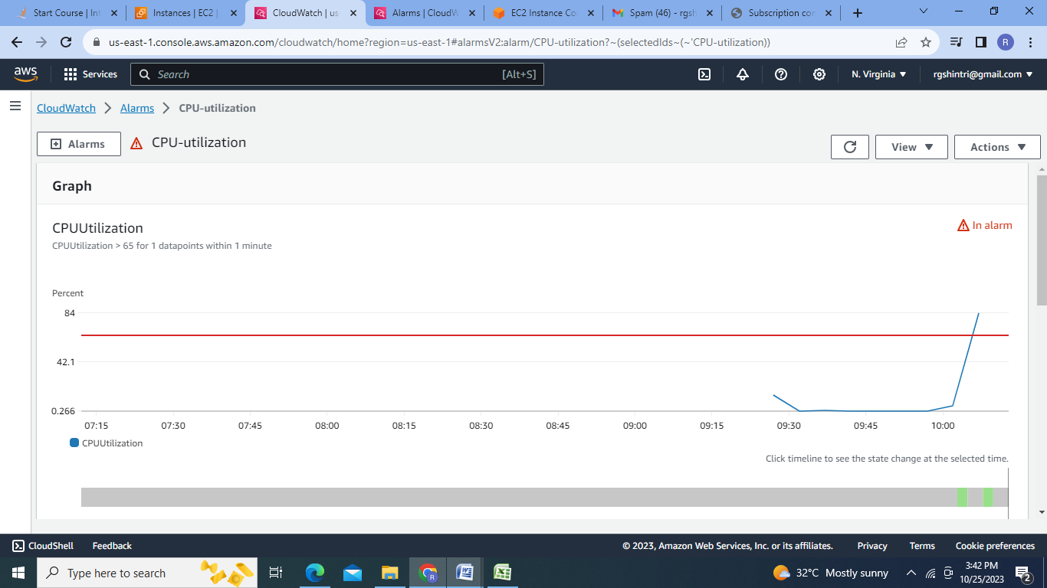

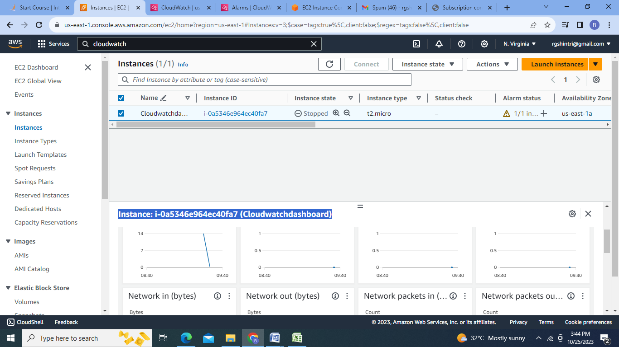

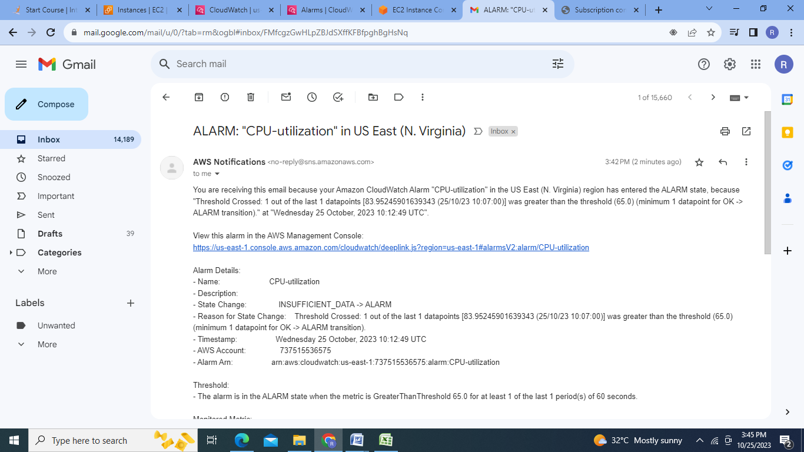

**Conclusion**: In this Assignment four IAM users are created, policies are created &attached with the IAM groups. IAM role is created & tested. dashboards& alarms are created for different metrics.

